VIDEO - Startup CEO: Balancing the Entrepreneurial Life

Startup CEO: Balancing the Entrepreneurial Life
Video: https://www.youtube.com/watch?v=NNQ696aiiq4

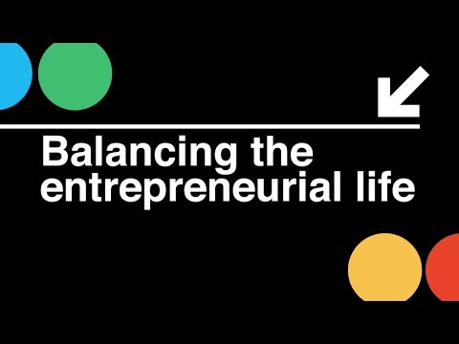

Description
©2015 Ewing Marion Kauffman Foundation. May not be used without permission. To enter a request for permission to use, contact FoundersSchool@kauffman.org.

Aus <https://www.youtube.com/watch?v=NNQ696aiiq4>

